VIDYAVARDHAKA COLLEGE OF ENGINEERING

**P.B. No.206, Gokulam, III - Stage, Mysore - 570 002, Karnataka, INDIA. Phone: +91 821 4276201 / 202 / 225.**

**DEPARTMENT OF INFORMATION SCIENCE AND ENGINEERING**



# DEVOPS LABORATORY 21IS62 (ACADEMIC YEAR 2023-24)

LAB MANUAL

# Department of Information Science and Engineering

**INSTITUTIONAL MISSION AND VISION**

## Vision

Vidyavardhaka College of Engineering shall be a leading institution in engineering and management education enabling individuals for significant contribution to the society.

## Mission

1. Provide the best teaching-learning environment through competent staff and excellent infrastructure.
2. Inculcate professional ethics, leadership qualities, communication and entrepreneurial skills to meet the societal needs.
3. Promote innovation through research and development.
4. Strengthen industry-institute interaction for knowledge sharing.

**DEPARTMENT OF INFORMATION SCIENCE AND ENGINEERING**

**Vision**

To be a premier Department for quality education in Information Science and Engineering creating competent professionals to meet the societal needs

**Mission**

1. Provide the best teaching-learning environment through proficient staff and excellent infrastructure

2. Inculcate professional values and entrepreneurial skills to fulfill the career and societal needs

3. Encourage innovations through research

4. Facilitate interaction with elite Institutions and Industries for knowledge sharing

**Program Educational Objectives (PEOs)**

1. Design optimal solution for information science related problems with in depth knowledge to become a successful professional

2. Become a responsible software engineer to address social challenges with professional values and entrepreneurial skills

3. Be sensitive to technological advances through continuous learning and research

## PROGRAM SPECIFIC OUTCOMES (PSO)

Students graduating in Information Science and Engineering will also be able to:

* PSO1: Evaluate the functioning of computer subsystems, interfaces and system software using appropriate tools.
* PSO2: Analyze, design, implement and test the information systems by applying
* suitable algorithms, data structures and object oriented technology.
* PSO3: Design and develop an efficient information system for storage, retrieval and visualization.
* PSO4: Provide secure solutions in the areas of Computer Networks and software Engineering.

## PROGRAM OUTCOMES (PO’S) BASED ON NBA GRADUATE ATTRIBUTES

**Engineering Graduates will be able to:**

1. **Engineering knowledge**: Apply the knowledge of mathematics, science, engineering fundamentals, and an engineering specialization to the solution of complex engineering problems.

2. **Problem analysis**: Identify, formulate, review research literature, and analyze complex engineering problems reaching substantiated conclusions using first principles of mathematics, natural sciences, and engineering sciences.

3. **Design/development of solutions**: Design solutions for complex engineering problems and design system components or processes that meet the specified needs with appropriate consideration for the public health and safety, and the cultural, societal, and environmental considerations.

4. **Conduct investigations of complex problems**: Use research-based knowledge and research methods including design of experiments, analysis and interpretation of data, and synthesis of the information to provide valid conclusions.

5. **Modern tool usage**: Create, select, and apply appropriate techniques, resources, and modern engineering and IT tools including prediction and modeling to complex engineering activities with an understanding of the limitations.

6. **The engineer and society**: Apply reasoning informed by the contextual knowledge to assess societal, health, safety, legal and cultural issues and the consequent responsibilities relevant to the professional engineering practice.

7. **Environment and sustainability**: Understand the impact of the professional engineering solutions in societal and environmental contexts, and demonstrate the knowledge of, and need for sustainable development.

8. **Ethics**: Apply ethical principles and commit to professional ethics and responsibilities and norms of the engineering practice.

9. **Individual and team work**: Function effectively as an individual, and as a member or leader in diverse teams, and in multidisciplinary settings.

10. **Communication**: Communicate effectively on complex engineering activities with the engineering community and with society at large, such as, being able to comprehend and write effective reports and design documentation, make effective presentations, and give and receive clear instructions.

11. **Project management and finance**: Demonstrate knowledge and understanding of the engineering and management principles and apply these to one’s own work, as a member and leader in a team, to manage projects and in multidisciplinary environments.

**12. Life-long learning**: Recognize the need for, and have the preparation and ability to engage in independent and life-long learning in the broadest context of technological change

# CONTENTS

|  |  |  |
| --- | --- | --- |
| Sl.no. | Experiments | Page No. |
| **A-Demonstration** | | |
|  | **A1**. Demonstrate and Create project in local and remote repository using GitBash and  GitHub and apply init, status, log, add, commit, push, config, clone and reset commands on repository. |  |
|  | **A2**. Demonstrate to create a project in remote repository and apply fork, merge, diff,  merge conflict, branch and pull request concepts on repository using GitHub. |  |
|  | **A3**. Demonstrate the process of integration github repository with Jenkins to automate  the project execution in CI/CD pipeline. |  |
| **B-Exercise** | | |
|  | **B1**. Create a docker image for an application stored in local repository and run the application using docker image. |  |
|  | **B2.** Create and configure Jenkins files for workflow and build of an application and  push the image |  |
| **C-Structured Inquiry** | | |
|  | **C1**. Create a maven projects with all dependencies required for the application in  CI/CD pipeline. |  |
|  | **C2**. Integrate communication channel with Jenkins for status of project and also  enable email notification for a build. |  |
| **D-Open Ended Problem** | | |
|  | **D1.** Create a Maven project and integrate all dependencies, integrate the project with github repository , integrate with docker and docker hub and create Continuous Integration / Continuous Deployment pipeline using Jenkins and enable email notification for status of build. |  |

## DevOps

Git

Git track changes via a distributed version control system. This means that Git can track the state of different versions of your projects while you're developing them. It is distributed because you can access your code files from another computer – and so can other developers.

When you're building an open source project, you'll need a way to document or track your code. This helps make your work organized, and lets you keep track of the changes you've made.

Operation of Git

* Manage projects with **Repositories**
* **Clone** a project to work on a local copy
* Control and track changes with **Staging** and **Committing**
* **Branch** and **Merge** to allow for work on different parts and versions of a project
* **Pull** the latest version of the project to a local copy
* **Push** local updates to the main project

### A1. Demonstrate and Create project in local and remote repository using GitBash and GitHub and apply init, status, log, add, commit, push, config, clone and reset commands on repository.

Git Init command

This command is used to create a local repository.

### Syntax

* + 1. $ git init Demo

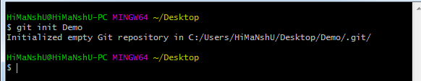

Git status command

The status command is used to display the state of the working directory and the staging area. It also lists the files that you've changed and those you still need to add or commit.

### Syntax

1. $ git status

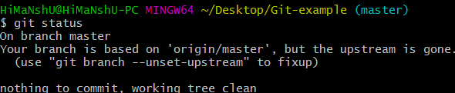

Git log Command

This command is used to check the commit history.

### Syntax

1. $ git log

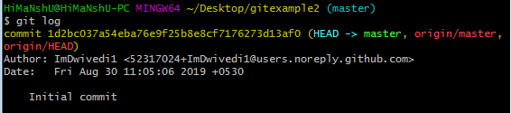

By default, if no argument passed, Git log shows the most recent commits first. We can limit the number of log entries displayed by passing a number as an option, such as -3 to show only the last three entries.

Git add command

This command is used to add one or more files to staging (Index) area.

### Syntax

To add one file

1. $ git add Filename To add more than one file

1. $ git add*

Git Commands

Git commit command

Commit command is used in two scenarios. They are as follows.

### Git commit -m

This command changes the head. It records or snapshots the file permanently in the version history with a message.

### Syntax

1. $ git commit -m " Commit Message"

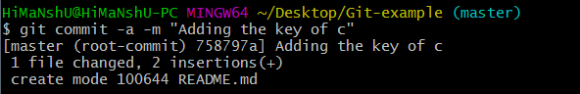

Git push Command

It is used to upload local repository content to a remote repository. Pushing is an act of transfer commits from your local repository to a remote repo. It's the complement to git fetch, but whereas fetching imports commits to local branches on comparatively pushing exports commits to remote branches.

**VVCE, MYSORE**

### Syntax

1. $ git push [variable name] master

Git Commands

*Git config command*

This command configures the user. The Git config command is the first and necessary command used on the Git command line.

### Syntax

1. $ git config --global user.name "ImDwivedi1"
2. $ git config --global user.email ["Him](mailto:Himanshudubey481@gmail.com)a[nshudube](mailto:Himanshudubey481@gmail.com)[y481@gmail.com"](mailto:y481@gmail.com)

Git clone command

This command is used to make a copy of a repository from an existing URL. If I want a local copy of my repository from GitHub, this command allows creating a local copy of that repository on your local directory from the repository URL.

### Syntax

1. $ git clone URL

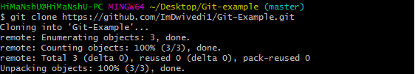

Git Reset

The term reset stands for undoing changes. The git reset command is used to reset the changes.

1. $ git reset --hard

Consider the below output:

Git Reset

### A2. Demonstrate to create a project in remote repository and apply fork, merge, diff, merge conflict, branch and pull request concepts on repository using GitHub.

Git Fork

A fork is a rough copy of a repository. Forking a repository allows you to freely test and debug with changes without affecting the original project.

It is a straight-forward process. Steps for forking the repository are as follows:

* Login to the GitHub account.
* Find the GitHub repository which you want to fork.
* Click the Fork button on the upper right side of the repository's page.

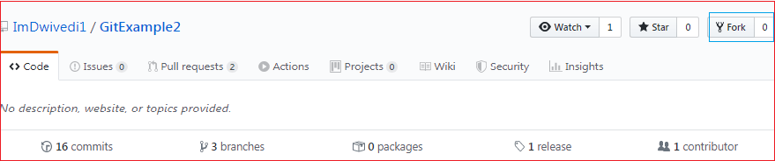

Git Merge

In Git, the merging is a procedure to connect the forked history. It joins two or more development history together. The git merge command facilitates you to take the data created by git branch and integrate them into a single branch.

1. $ git merge master See the below output:

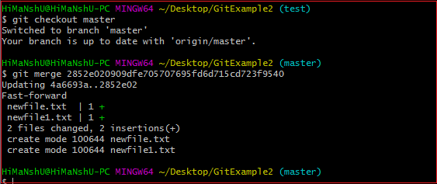

Git Diff

It compares the different versions of data sources. The version control system stands for working with a modified version of files. So, the diff command is a useful tool for working with Git.

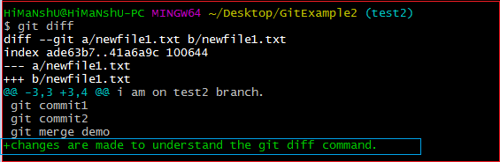

*Git Merge Conflict*

When two branches are trying to merge, and both are edited at the same time and in the same file, Git won't be able to identify which version is to take for changes. Such a situation is called merge conflict.

$ mkdir git-merge-test

$ cd git-merge-test

$ git init .

$ echo "this is some content to mess with" > merge.txt

$ git add merge.txt

$ git commit -am"we are commiting the inital content"

[main (root-commit) d48e74c] we are commiting the inital content 1 file changed, 1 insertion(+)

create mode 100644 merge.txt

$ git checkout -b new_branch_to_merge_later

$ echo "totally different content to merge later" > merge.txt

$ git commit -am"edited the content of merge.txt to cause a conflict" [new_branch_to_merge_later 6282319] edited the content of merge.txt to cause a conflict 1 file changed, 1 insertion(+), 1 deletion(-)

$ git merge new_branch_to_merge_later Auto-merging merge.txt

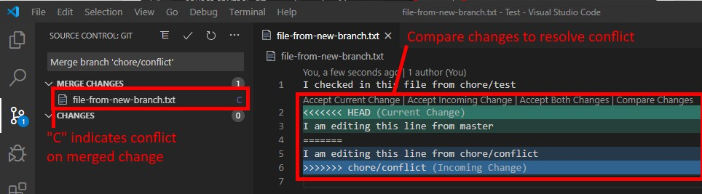

CONFLICT (content): Merge conflict in merge.txt

Automatic merge failed; fix conflicts and then commit result

Git Pull

The term pull is used to receive data from GitHub. It fetches and merges changes from the remote server to your working directory. The **git pull command** is used to pull a repository.

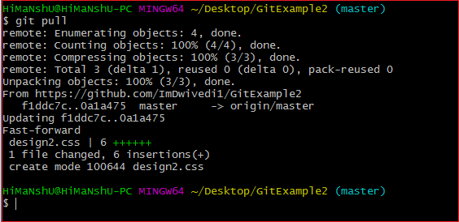

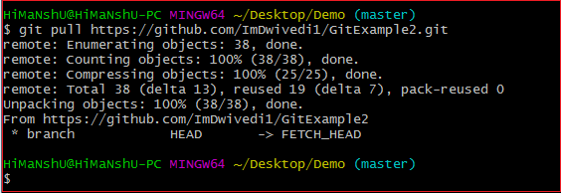

Git Branch

A branch is a version of the repository that diverges from the main working project. It is a feature available in most modern version control systems. A Git project can have more than one branch.

Create Branch

You can create a new branch with the help of the **git branch** command. This command will be used as:

### Syntax:

1. $ git branch **<branch** name**> Output:**

Git Branch

List Branch

You can List all of the available branches in your repository by using the following command.

1. $ git branch

### Git BranchOutput:

1. $ git branch -d**<branch** name**> Output:**

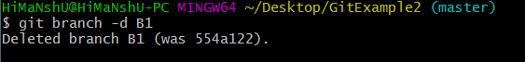

### A3. Demonstrate the process of integration github repository with Jenkins to automate the project execution in CI/CD pipeline.

Install Jenkins on Windows

1. Install Java Development Kit (JDK)
2. Download JDK 8 and choose windows 32-bit or 64-bit according to your system configuration. Click on "accept the license agreement." Set the Path for the Environmental Variable for JDK.

•Go to System Properties. Under the "Advanced" tab, select "Environment Variables."

•Under system variables, select "new." Then copy the path of the JDK folder and paste it in the corresponding value field. Similarly, do this for JRE.

•Under system variables, set up a bin folder for JDK in PATH variables.

•Go to command prompt and type the following to check if Java has been successfully installed:

1. Download and Install Jenkins
2. Download Jenkins. Under LTS, click on windows.

•After the file is downloaded, unzip it. Click on the folder and install it. Select "finish" once done.

* + 4. Run Jenkins on Localhost 8080

•Once Jenkins is installed, explore it. Open the web browser and type "localhost:8080".

•Enter the credentials and log in. If you install Jenkins for the first time, the dashboard will ask you to install the recommended plugins. Install all the recommended plugins.

1. Jenkins Server Interface

•New Item allows you to create a new project.

•Build History shows the status of your builds.

•Manage System deals with the various configurations of the system.

1. Build and Run a Job on Jenkins

•Select a new item (Name - Jenkins_demo). Choose a freestyle project and click Ok.

•Under the General tab, give a description like "This is my first Jenkins job." Under the "Build Triggers" tab, select add built step and then click on the "Execute Windows" batch command.

•In the command box, type the following: echo "Hello... This is my first Jenkins Demo:

%date%: %time% ". Click on apply and then save.

•Select build now. You can see a building history has been created. Click on that. In the console output, you can see the output of the first Jenkins job with time and date. Project configuration

* 1. Install python interpreter on local machine.
  2. Write python script and debug the program for any errors.

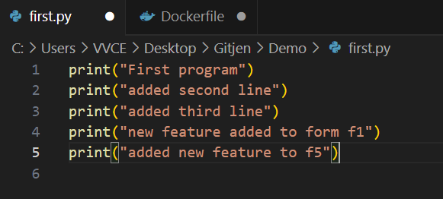

* 1. Push the project into git repository.

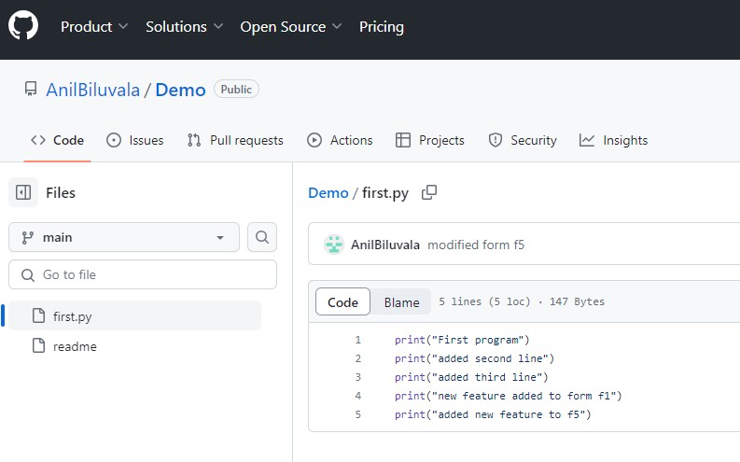

* 1. Launch the jenkins and configure the pipeline.

Configuration of Jenkins

1. Create new project and provide name for the project. Choose “Freestyle Project”.

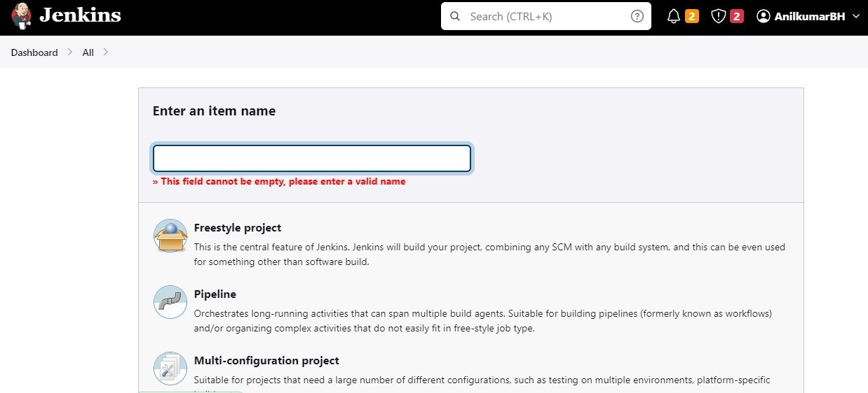

1. Click on newly created project and move to configuration. Under source Code Management provide git repository.

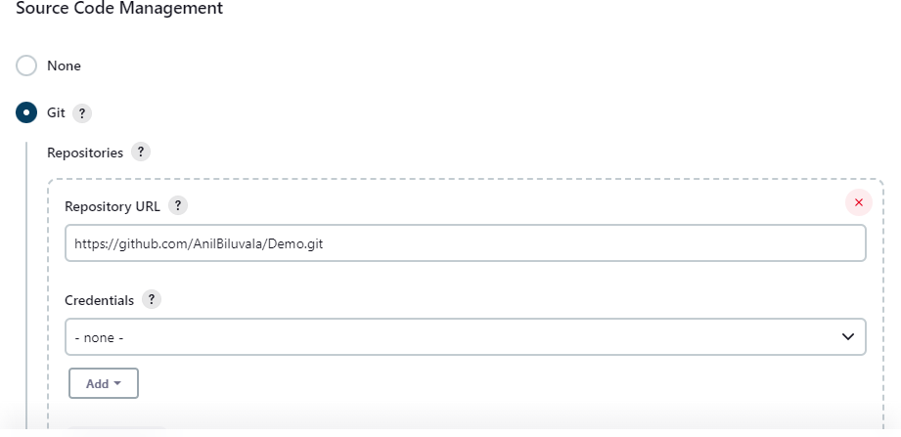

1. Provide branch name where project is located.

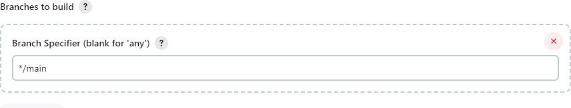

1. Under Build Triggers select Poll SCM and configure the schedule according to your project.

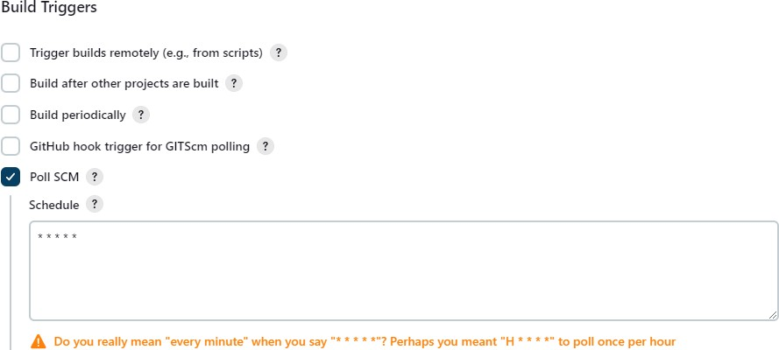

1. In build steps choose “Execute Windows batch command” and provide command for execution.

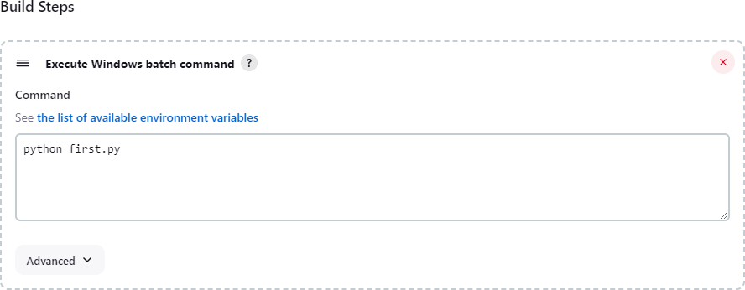

1. Apply and save your configuration.
2. Click on “Build Now” for detailed output click on “Console Output” and verify the process. Finally build status will be displayed according to your project implementation.

**B-Exercise**

**[21IS62-DEVOPS LAB]**

14

### B1. Create a docker image for an application stored in local repository and run the application using docker image.

Introduction to Docker

Docker is an open platform for developing, shipping, and running applications. Docker enables

you to separate your applications from your infrastructure so you can deliver software quickly. With Docker, you can manage your infrastructure in the same ways you manage your applications. By taking advantage of Docker's methodologies for shipping, testing, and deploying code, you can significantly reduce the delay between writing code and running it in production.

Docker architecture

Docker uses a client-server architecture. The Docker client talks to the Docker daemon, which does the heavy lifting of building, running, and distributing your Docker containers. The Docker client and daemon can run on the same system, or you can connect a Docker client to a remote Docker daemon. The Docker client and daemon communicate using a REST API, over UNIX sockets or a network interface. Another Docker client is Docker Compose, that lets you work with applications consisting of a set of containers.

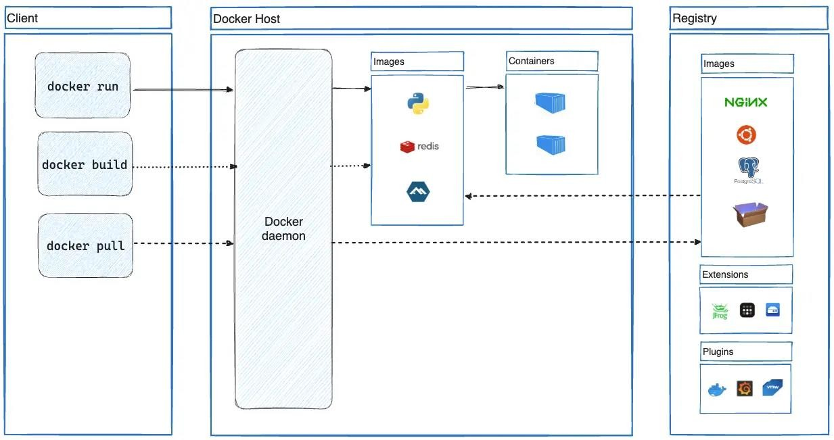

Install Docker Desktop on Windows System requirements

* WSL version 1.1.3.0 or later.
* Windows 11 64-bit: Home or Pro version 21H2 or higher, or Enterprise or Education version 21H2 or higher.
* Windows 10 64-bit:
* We recommend Home or Pro 22H2 (build 19045) or higher, or Enterprise or Education 22H2 (build 19045) or higher.
* Minimum required is Home or Pro 21H2 (build 19044) or higher, or Enterprise or Education 21H2 (build 19044) or higher.
* Turn on the WSL 2 feature on Windows. For detailed instructions, refer to the Microsoft documentationopen_in_new.

The following hardware prerequisites are required to successfully run WSL 2 on Windows 10 or Windows 11:

* 64-bit processor with Second Level Address Translation (SLAT)open_in_new
* 4GB system RAM
* Enable hardware virtualization in BIOS. For more information, see Virtualization. Configuration of Java applications

1. Install prerequisites for java applications like jdk tool.
2. Configure environment variables for jdk.

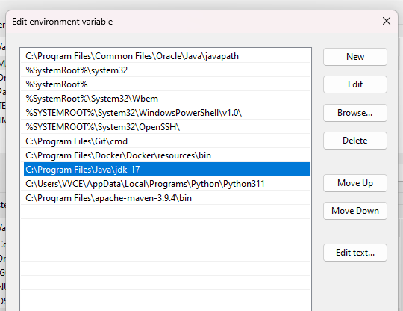

1. Create java application.

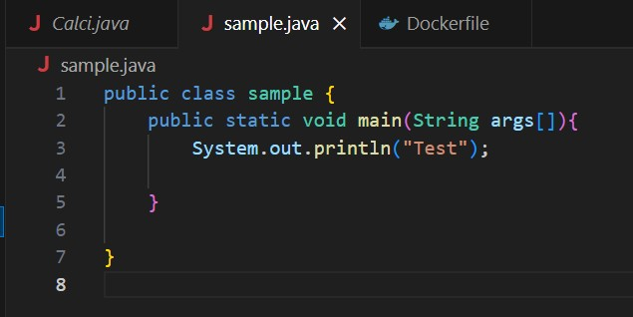

1. Create Dockerfile where configuration details are provided for creating image.

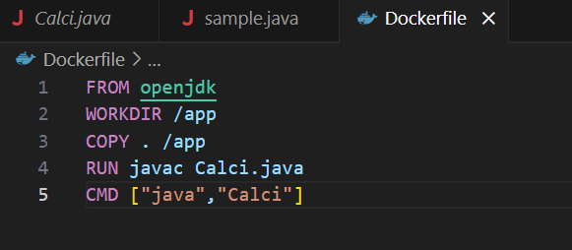

1. Complile the java program for any errors.
2. Create image for the application.

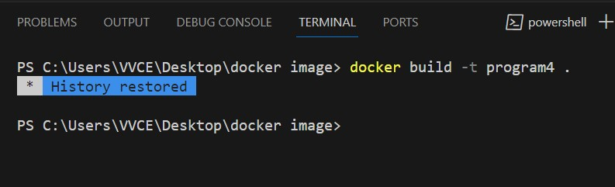

1. Run the application using docker image.

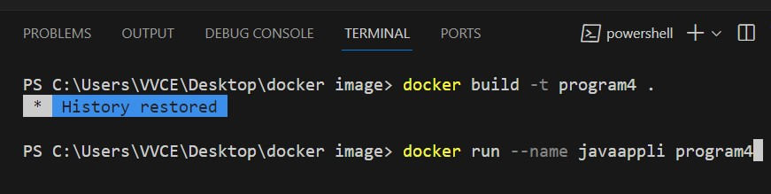

**B2.** Create and configure Jenkins files for workflow and build of an application and push the image on docker hub.

Configuration Steps:

1. Go to Jenkins and configure docker plug-ins.

Install

* 1. [CloudBees Docker Custom Build EnvironmentVersion1.7.3](https://plugins.jenkins.io/docker-custom-build-environment)
  2. [Docker](https://plugins.jenkins.io/docker-plugin)
  3. [Docker Compose Build Step](https://plugins.jenkins.io/docker-compose-build-step)

Make sure that these three plug-in must be installed.

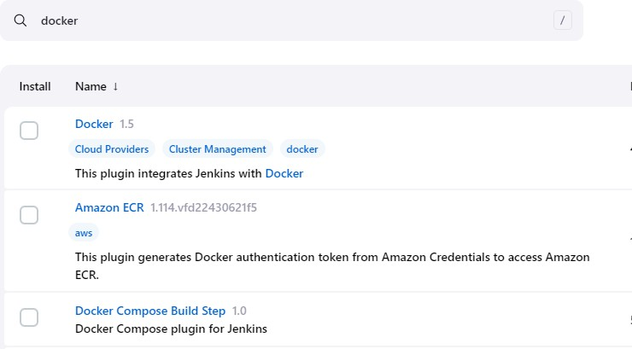

1. Create a pipeline project

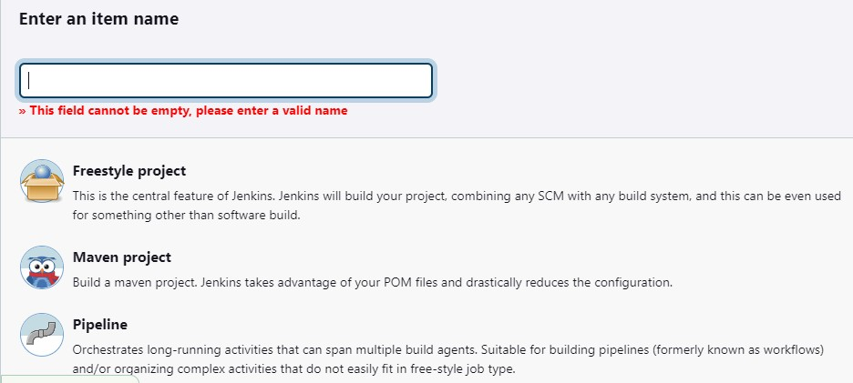

1. Go to project configuration add pipeline script under “Advanced project Options”

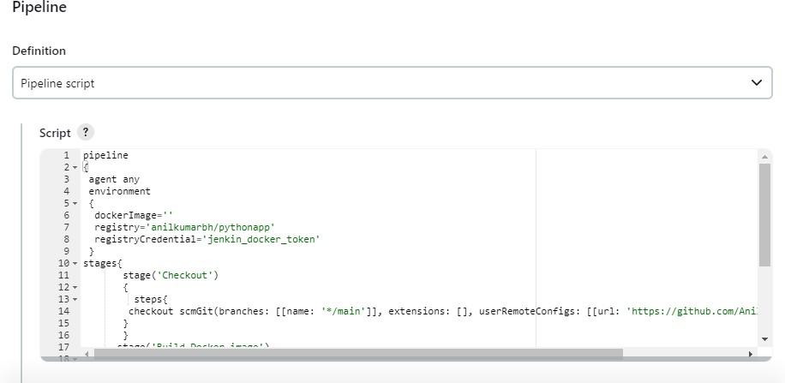

pipeline

{

agent any environment

{

dockerImage='' registry='anilkumarbh/pythonapp' registryCredential='jenkin_docker_token'

}

stages{

stage('Checkout')

{

steps{

checkout scmGit(branches: [[name: '*/main']], extensions: [], userRemoteConfigs: [[url: 'https://github.com/AnilBiluvala/dpipeline.git']])

}

}

stage('Build Docker image')

{

steps{ script{

dockerImage=docker.build registry

}

}

}

}

}

In script add git url, docker hub credentias, docker hub image name.

Save the configuration and run the build. Image will be created.

1. Push the image to docker hub.

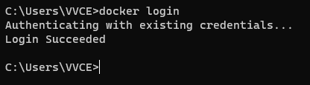

Provide docker hub crdentials.

1. Tag the image to be pushed.

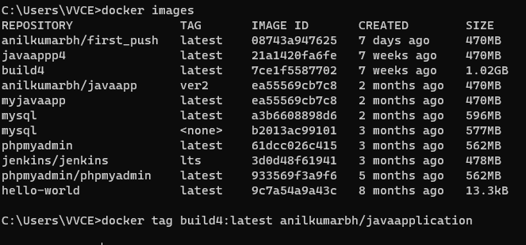

docker tag <reponame>:<tagname> <hubname>/<display name>

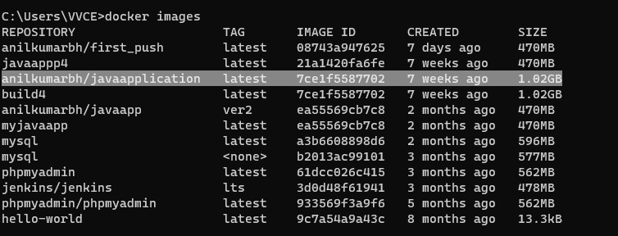

1. Push the image to hub.

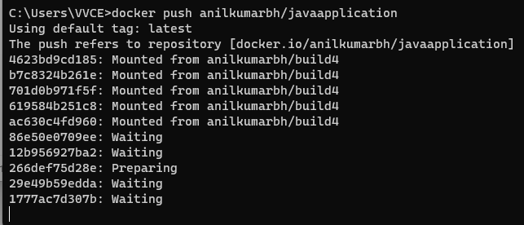

1. Image will be available in docker hub.

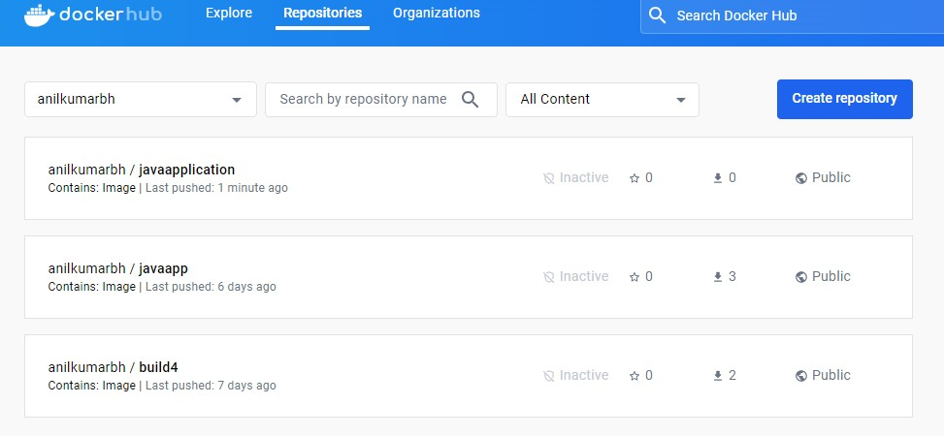

**C-Structured Inquiry**

**C1**. Create a maven projects with all dependencies required for the application in CI/CD pipeline.

Required tools:

1. Eclipse IDE
2. Maven repository
3. JSON

Reading data from JSON file. Create JSON file

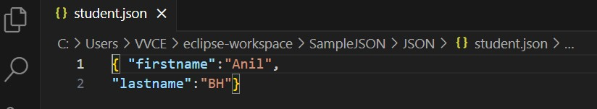

Save the data.

1. Create maven project

New Project -> Others -> select maven project

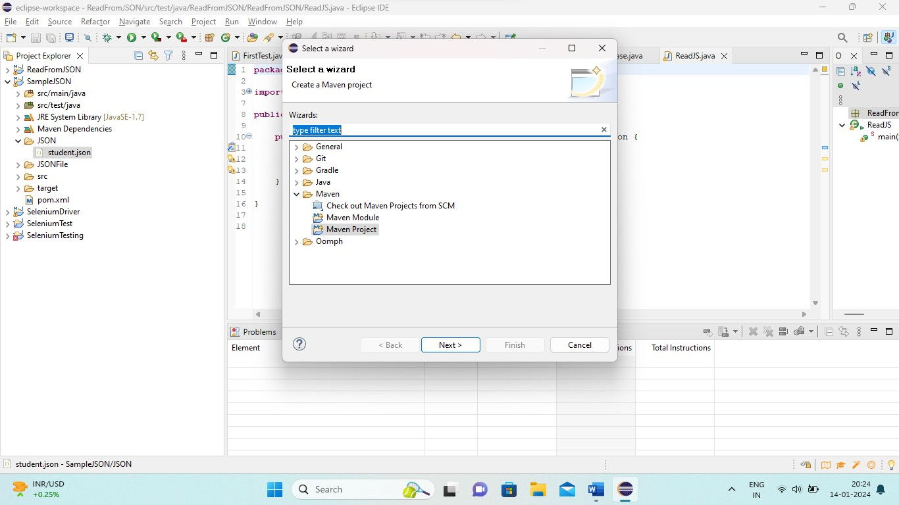

Provide project name

1. Create folder “JSON” and add .json file to it.

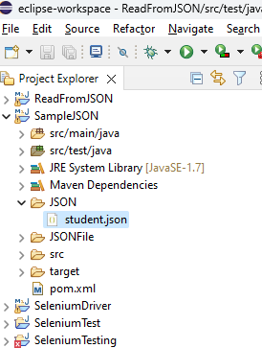

1. Adding JSON dependency to the project in POM.xml file.

Procedure to add dependency Step1 : Go to maven repository Stept2 : search simple json

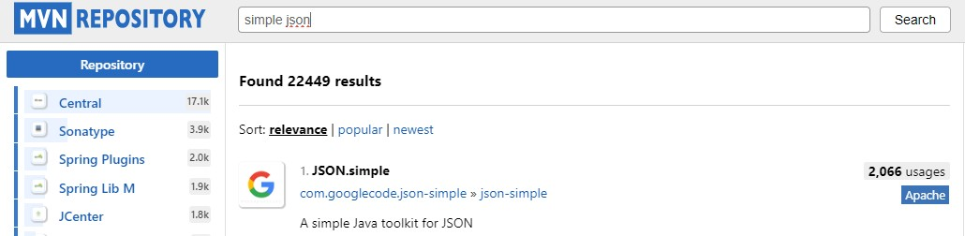

Step3 : choose relevant based on highest usages. Setp4: choose version

Stept5: copy the dependency.

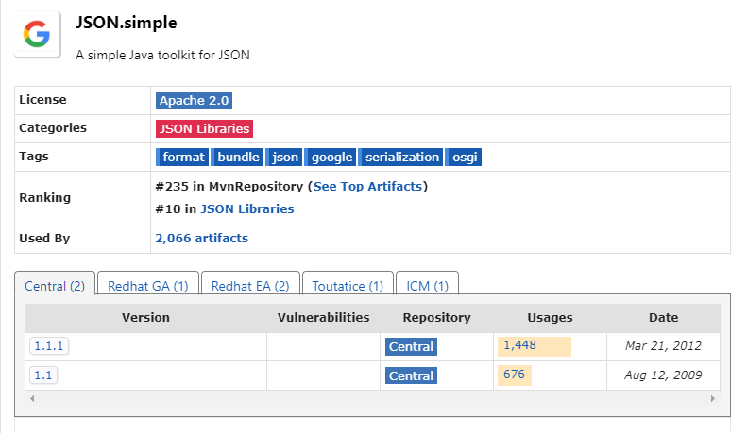

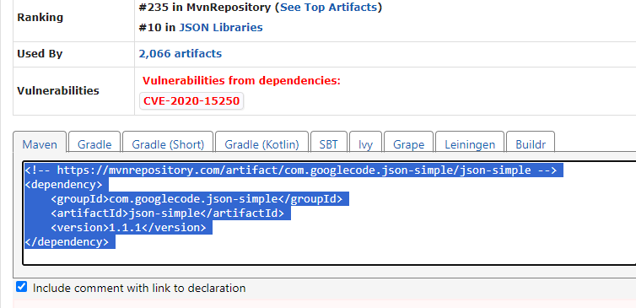

Step6: Open POM.xml and add dependency.

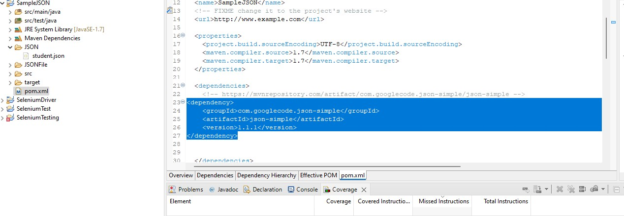

Program to read data from JSON. Create a class under src/test/java

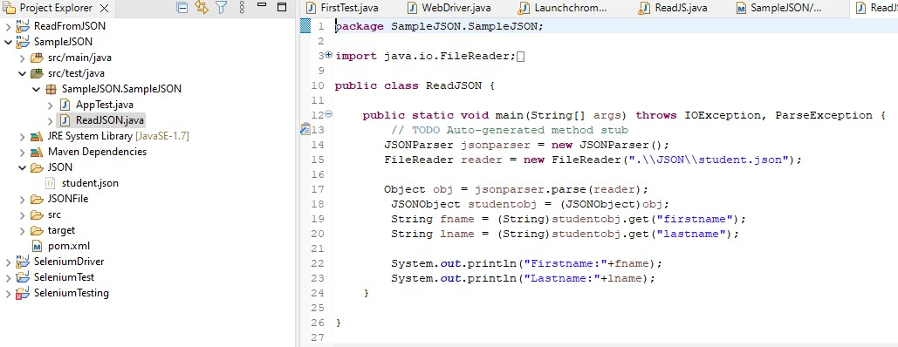

Run the program it will fetch data from JSON file

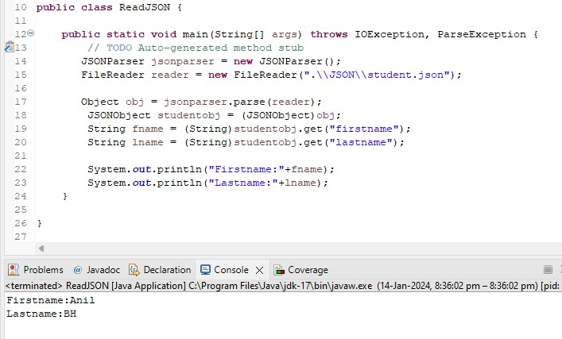

**C2**. Integrate communication channel with Jenkins for status of project and also enable email notification for a build.

Communication Channel : Slack Slack installation :

1. Install slack application. Create account in slack.
2. Create new workgroup or use existing workgroup, add new channel under group.

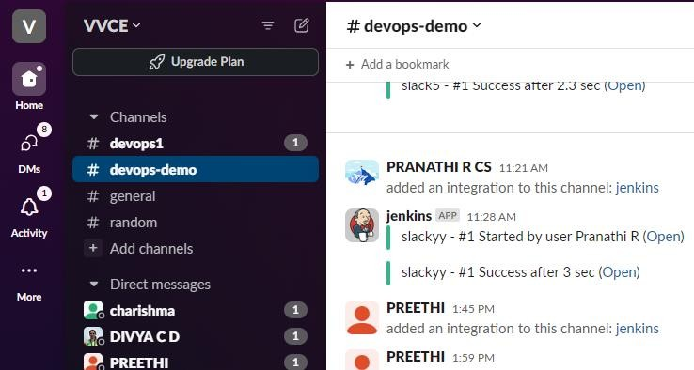

Jenkins configuration:

1. Add slack notifications plug-in in jenkins.

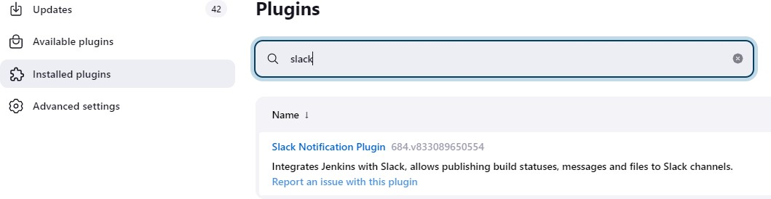

1. Click on installed plug-in

It will redirect to notifications page

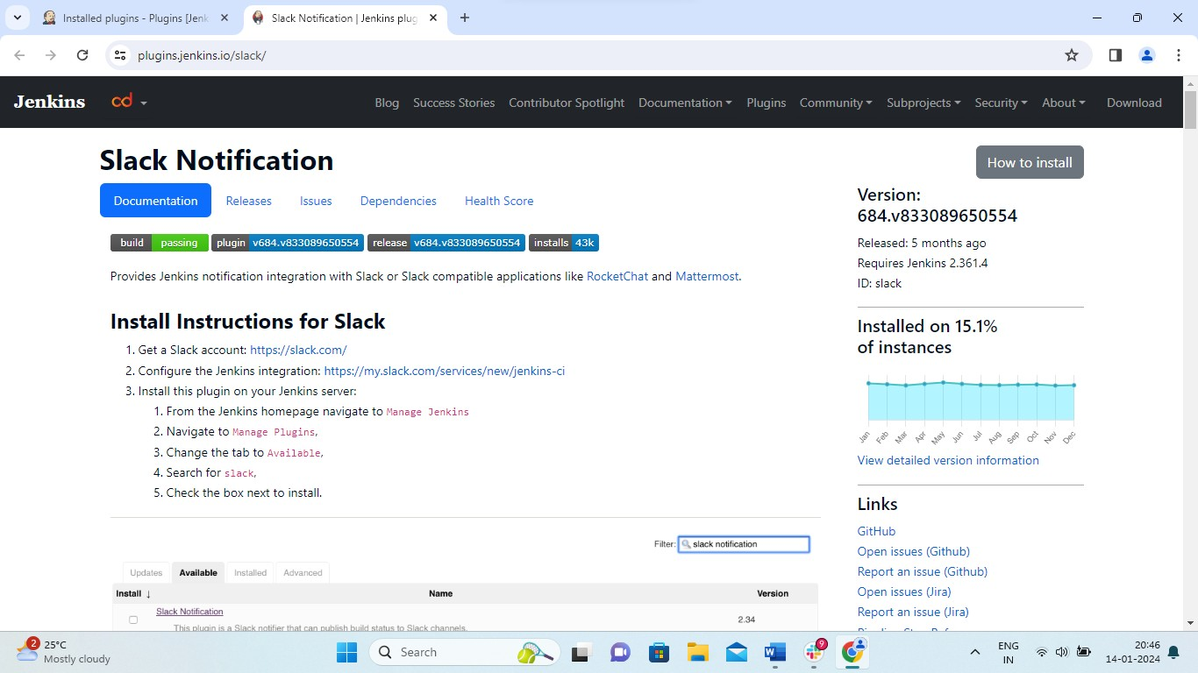

1. click on “Configure the Jenkins integration:” choose posting channel

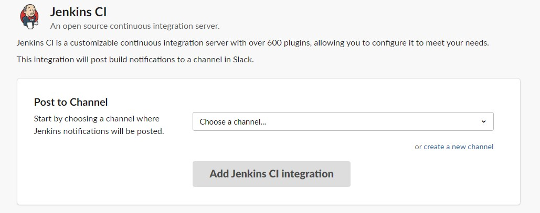

1. after choosing channel it will redirec to next page and note down “**Integration Token Credential ID”**
2. Create free style project.
3. Confiugation of project:

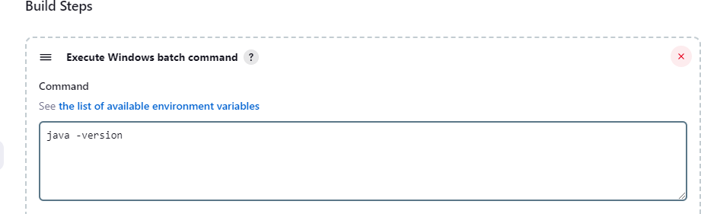

1. Add post build action and choose notifications.

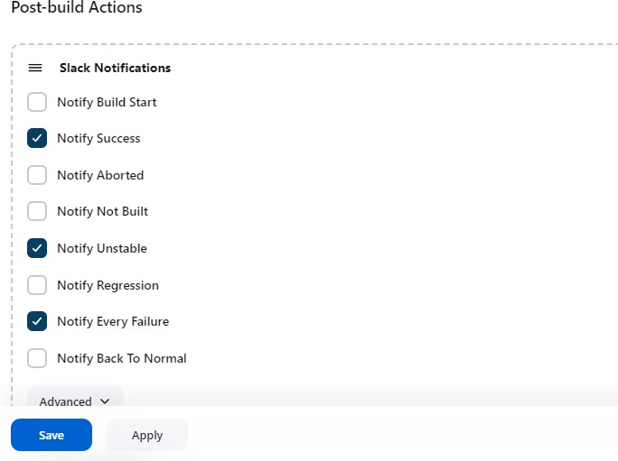

1. Save the configuration and run the build.
2. Notification will be triggered from jenkins. User will get the notification in channel.

